**Math 155, *Lecture Notes- Bonds* Name____________**

***Section 10.3*** *Parametric Equations and Calculus*

Now that we can graph parametric equations, we can consider extending the concepts of continuity and differentiation to these curves. How do we find equations of tangent lines? How do we take higher order derivatives? How do we find concavity? What will Arc Length look like with parametric equations?

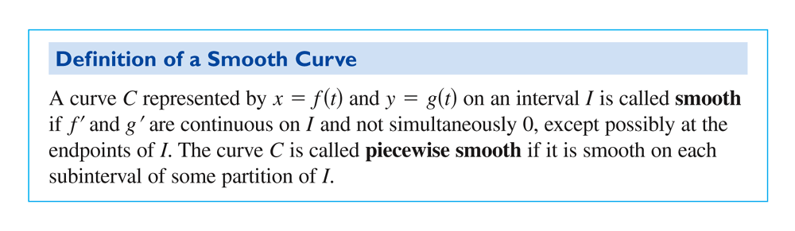

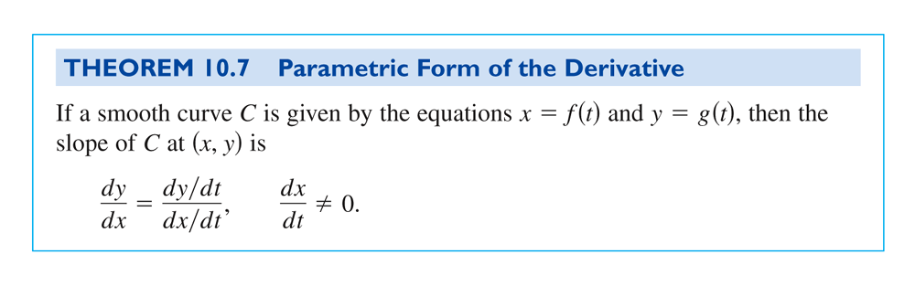

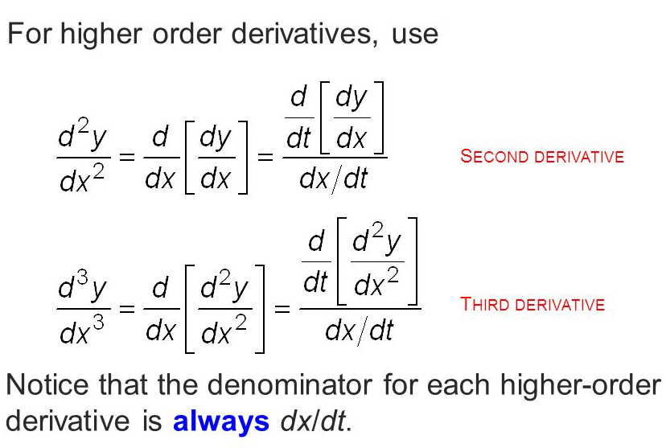

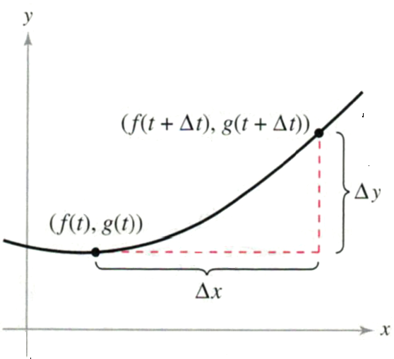

**Ex. 1:** Find  for 

**Ex. 2:** Find  and  for  at .

**More Ex. 2:**

**Ex. 3:** Find  and  for  at .

**More Ex. 3:**

**Ex. 4:** Find the equation of the tangent line to the curve, C, defined by the equation  at the point M, , .

**More Ex. 4:**

**More Ex. 4:**

**Ex. 5:** Find the equations of the tangent line at the point where the curve crosses itself.



**More Ex. 5:**

**More Ex. 5:**

If  and  when , then the parametric curve represented by  and  has a **horizontal tangent** at .

If  and  when , then the parametric curve represented by  and  has a **vertical tangent** at .

If  **and**  when , then  yields and indeterminate form. We need to study this situation on a case-by case-basis and we must consider the graph behavior near this point on the curve, since the indeterminate form cannot tell us what is happening.

**Ex. 6:** Find the points of horizontal tangency and vertical tangency.



**Ex. 7:** Determine the t-intervals on which the curve is concave downward, or concave upward.



**More Ex. 7:**

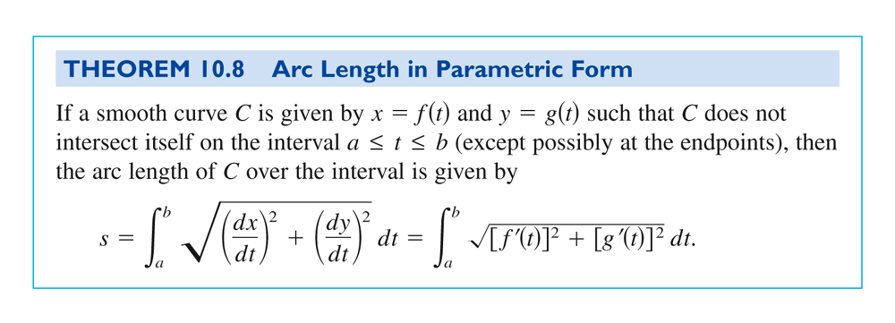

**Ex. 8:** Write an integral that represents the arc length of the curve over .



**Ex. 9:** Find the circumference of a circle with radius *a*.

